**Statistics - Practice Exercises**

This data set titanic_data provides information on the fate of passengers on the fatal maiden voyage of the ocean liner "Titanic", summarized according to economic status (class), sex, age and survival.

**Dataset Name:** titanic_train (Titanic Passenger Survival Dataset)

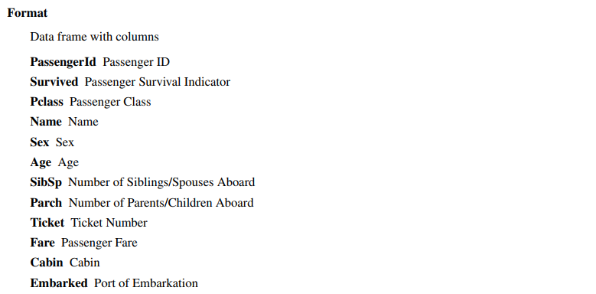

**Table View: Titanic_train**

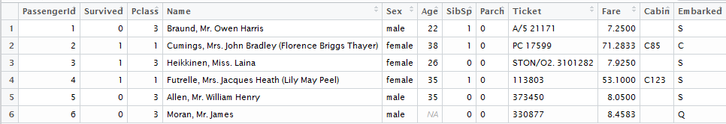

**Practice Exercises:**

1. Use titanic data 🡪 library(titanic)
2. titanic_train is used in the dataset

data("titanic_train")

head(titanic_train)

1. Compute the descriptive statistics on age variable 🡪 summary(titanic_train$Age)
2. Compute descriptive statistice on Fare variable  🡪 summary(titanic_train$Fare)
3. Compute the measures of spread for age and Fare variable
4. Variance, Standard deviation and IQR
5. Select a random sample of 500 records from titanic_train
6. Compute the mean fare by PClass
7. Seperate the records of all the classes and compute the mean
8. Assuming the age is following normal distribution
9. What is the propability of a person with age greater than 50

use pnorm

1. what is the propability of fiding a person between the age of 40 and 50?
2. what is 75th percentile age?
3. age of the 95% of the people ( lower(2.5%) and upper(97.5%))?
4. Plot the probability density of age variable
5. Compute Z values for Fare variable
6. Convert the Fare into standard normal values
7. Is there a difference in mean age of Males anf Females on Titanic?
8. Set a Alternate hypothesis and Null hypothesis
9. Alternate hypothesis is Mean age of Men is greater than mean age of females
10. What is the propability of survival?
11. what is the propability of survial for Males?
12. what is the propability of survival of females?
13. what is the propability of survival for females in second class?
14. what is the propability of survival for males in second class?
15. compute the odss of survival of Males
16. compute the odds of survival for females
17. Odds ratio of survival of males vs females ?
18. Perfrom hypothesis testing on survival of Males vs Survival of females

table(titanic_train$Sex, titanic_train$Survived)

chisq.test(table(titanic_train$Sex, titanic_train$Survived))

hist(titanic_train$Age)